SUGAR SKULL October 30, 2026 7:30PM
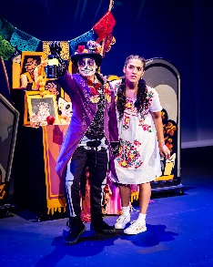
Meet Sugar Skull, a charismatic skeleton with a secret or two. With her skeletal new friend, Vita dances with ancient ancestors, sings with a sorrowful sorceress, escapes the trickster Chaneques, and even meets the famous Catrina Calavera. But can this clever youth gather the missing pieces needed for her Family ofrenda before it’s too late!
Ticket pricing for Girl Scouts and Families: $20.14, $28.23, $36.32, $44.42, $52.51

Gravity and Other Myths: November 13, 2026 7:30pm
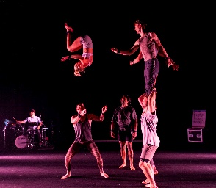
Everybody is a master of something. Blink, step, jump, balance, flip, fly. This is an ode to the countless hours needed to achieve great things. A tribute to the dedication required to realize our physical ambitions. An acknowledgement of the backstory that is often more spectacular than the finished product. Eight world class acrobats investigate physical skill; how we obtain it, how we perfect it, and how it can transform our lives. Through highlighting the nuance of high-level acrobatics, audiences experience a heightened appreciation of the countless hours required to master the skills they are witnessing. This is a love letter to our bodies and the amazing things they let us do every day. This is an invitation to watch us work.
Ticket Pricing for Girl Scouts and Families: $36.32, $28.23, $24.19

To order tickets 1-10 please use this link or QR Code, 10 or more, please call 414-273-7207, email groupsales@marcuscenter.org, no down payment needed on groups of 10 or more while you work on a final count.

https://am.ticketmaster.com/mcpa/promotional-page?id=MzM=
